Goal

I like to show the relationships in this diagram in a Matrix Report.

|  |  |
| --- | --- |
|  |  |

Insert Matrix Report

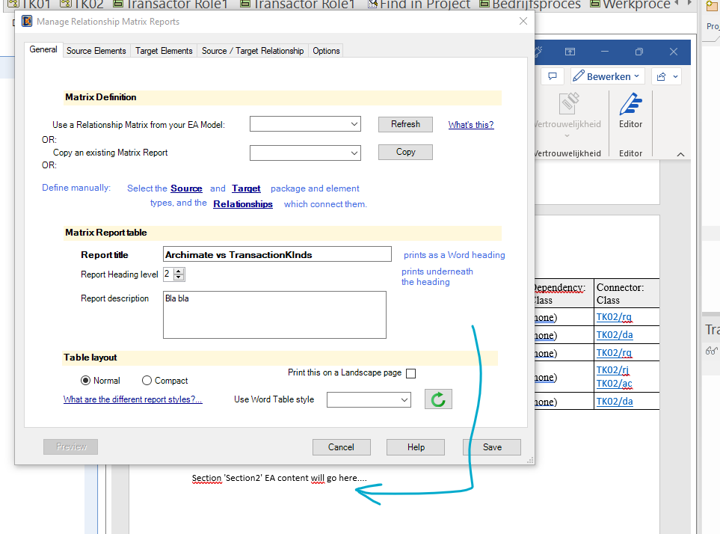

Set Source:

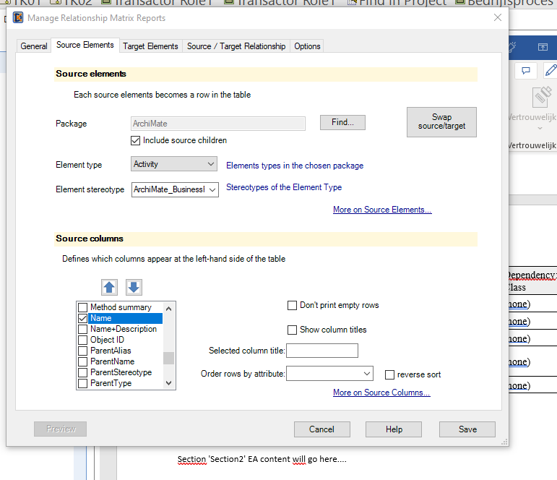

This seems to work as expected….

Set Target

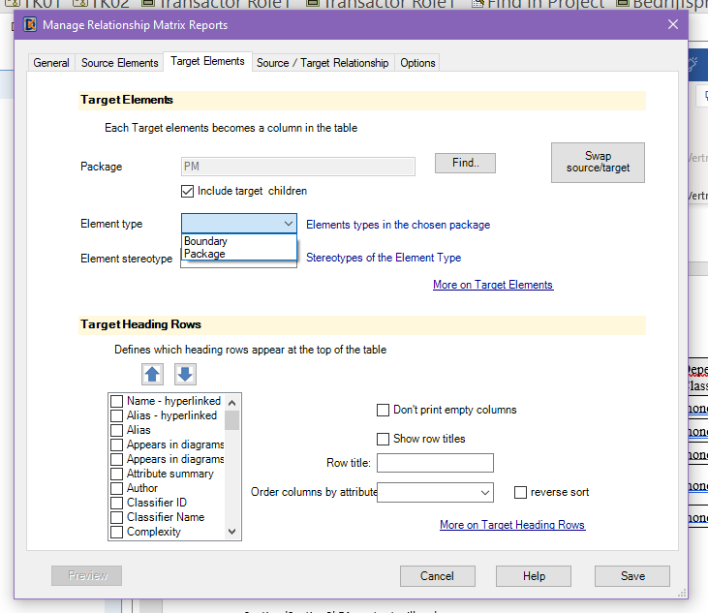

This element type selection looks a bit too narrow…

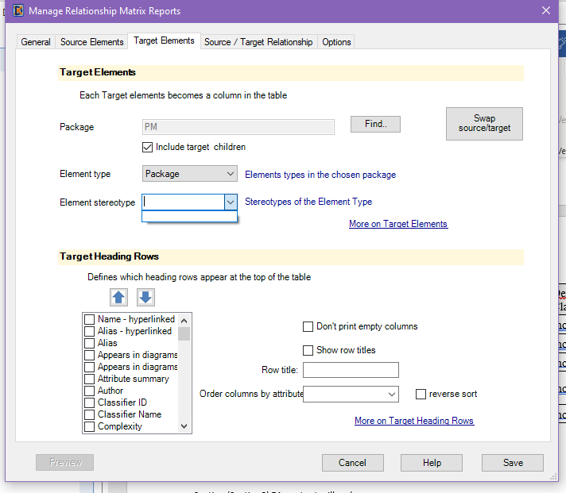

So it does not show Element Stereotype.

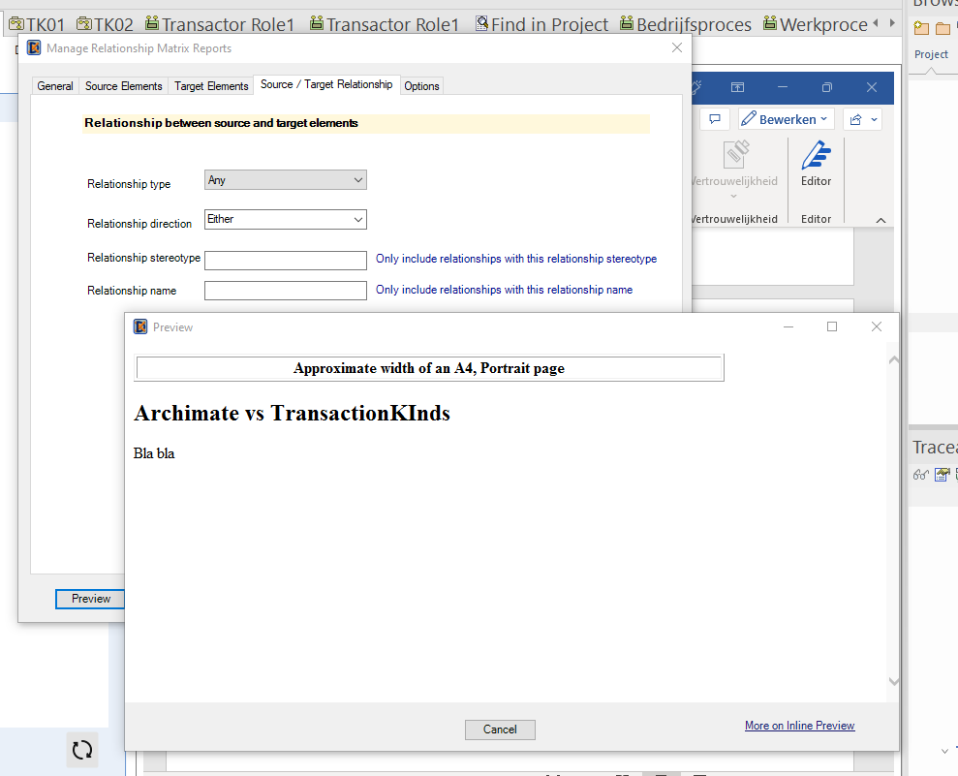

When I go one level deeper…

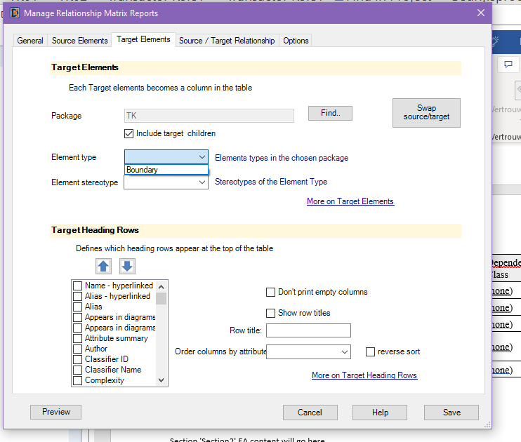

Then I still like to Save this, though it is not complete

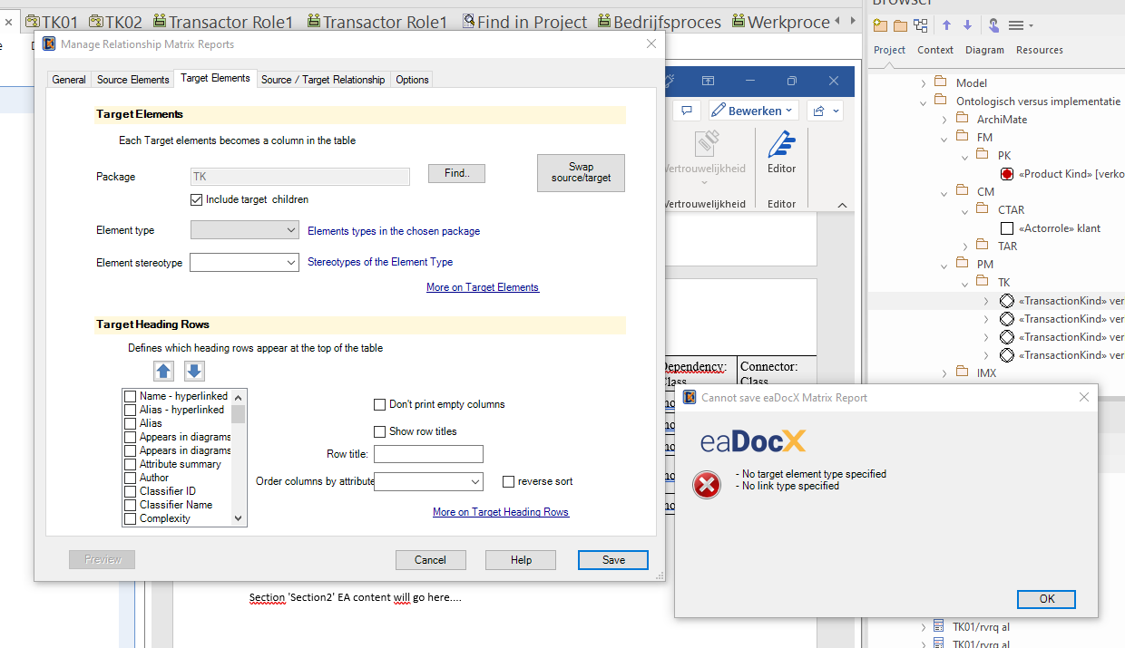

But the section is not created. Which might be okay. I cannot reopen this faulty Matrix Report.

